KP26 -

Functionality
Indirect Activity will be applied to allocate planned employees cost (total payroll of R&T/STC) to research projects/orders based on the productive and non-productive research hours worked for each project.
To accomplish this, the total annual activity for productive (3RTP01) and non productive hours (3RTN01) must be planned on the sender cost center.

Scenario
The document shows how to plan the activity output on a sender cost center.

Prerequisites
Cost center and activity type master data must have been created.

Menu Path | Accounting → Controlling → Cost Center Accounting → Planning → Activity Output/Prices → KP26 - Change
Transaction Code | KP26

1. Double Click on KP26 - Change

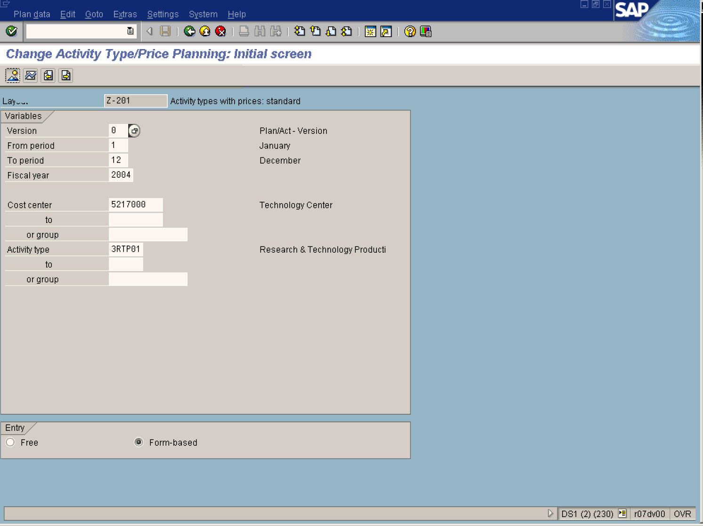
2. To set the planner profile use the following menu path: SettingsSet planner profile.

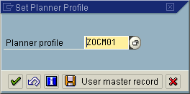
3. Update the following fields:
Field Name | Description | Values
Planner profile | Description of the Planner profile. | Example: zocm01
4. Click User master record Button to save .

5. Update the following fields:

Field Name | Description | Values
Version | Controlling area related collection of year-dependent indicators for planning data. | Example: 0
From Period | Number identifying a fiscal month | Example: 1
To Period | Number identifying a fiscal month | Example: 12
Fiscal Year | The fiscal year can be the same as the calendar year, but does not have to be. | Example: 2004
Cost center | Code identifying an organizational unit to which costs or assets are assigned | Example: 5217000
Activity type | Activity types describe the activity produced by a cost center and are measured in units of time or quantity. | Example: 3RTP01
6. Click <radio button> Form-based .

Note: Activity type group could also be used to plan 3RTP01 and 3RTN01 simultaneously. Use activity group for R&T activity.

Note: If you activate the "Form-based planning" indicator, all objects with valid master data are displayed, regardless of whether the objects have been already planned or not. The same structure of characteristic values is displayed in each planning session.

7. Click Enter .
8. Click Overview Button .

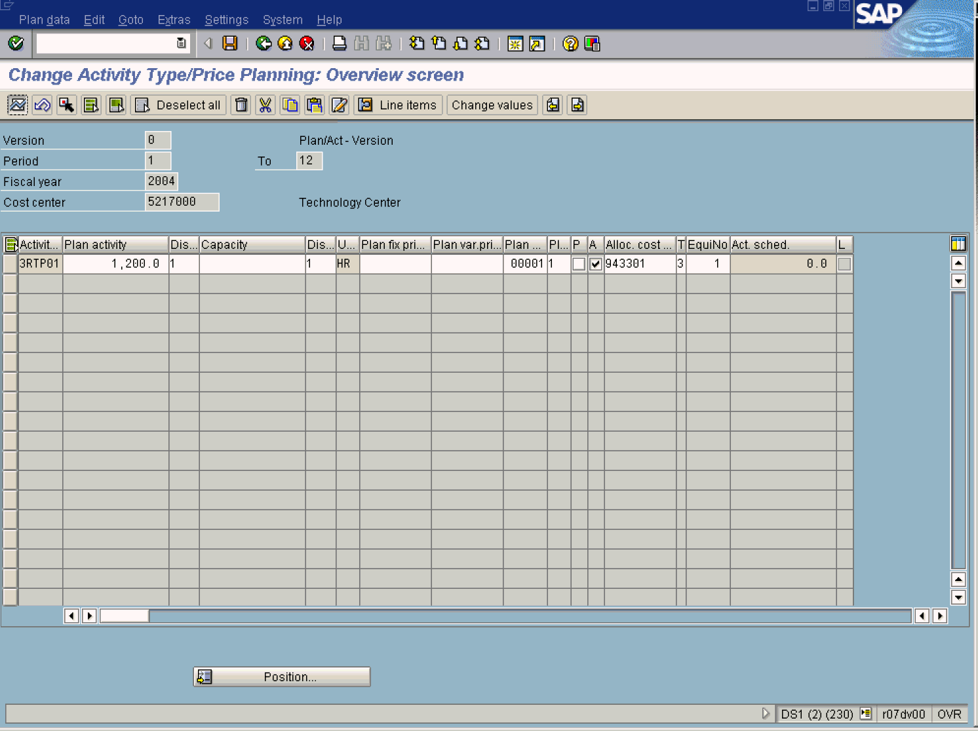

9. Update the following fields:

Field Name | Description | Values
Plan activity | Number of hours. | Example: 1200
10. Click Enter to check your entries.
11. Click Period screen Button . This is used to split the planned activity into quantities per period.

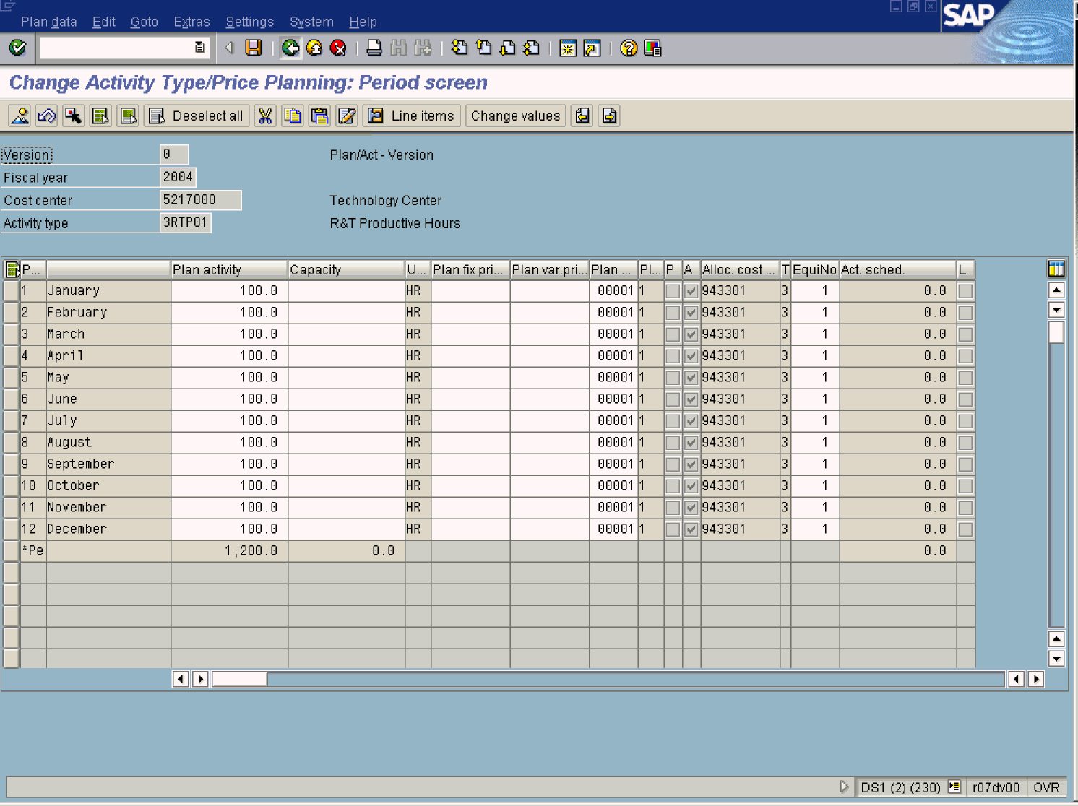
12. Click Enter to accept the entered data.
Note: The activity quantity has been evenly distributed over 12 periods. This equal distribution is set by the Distribution Key on the previous overview page. These values can be changed.
13. Click Back to go back to the planning overview screen.

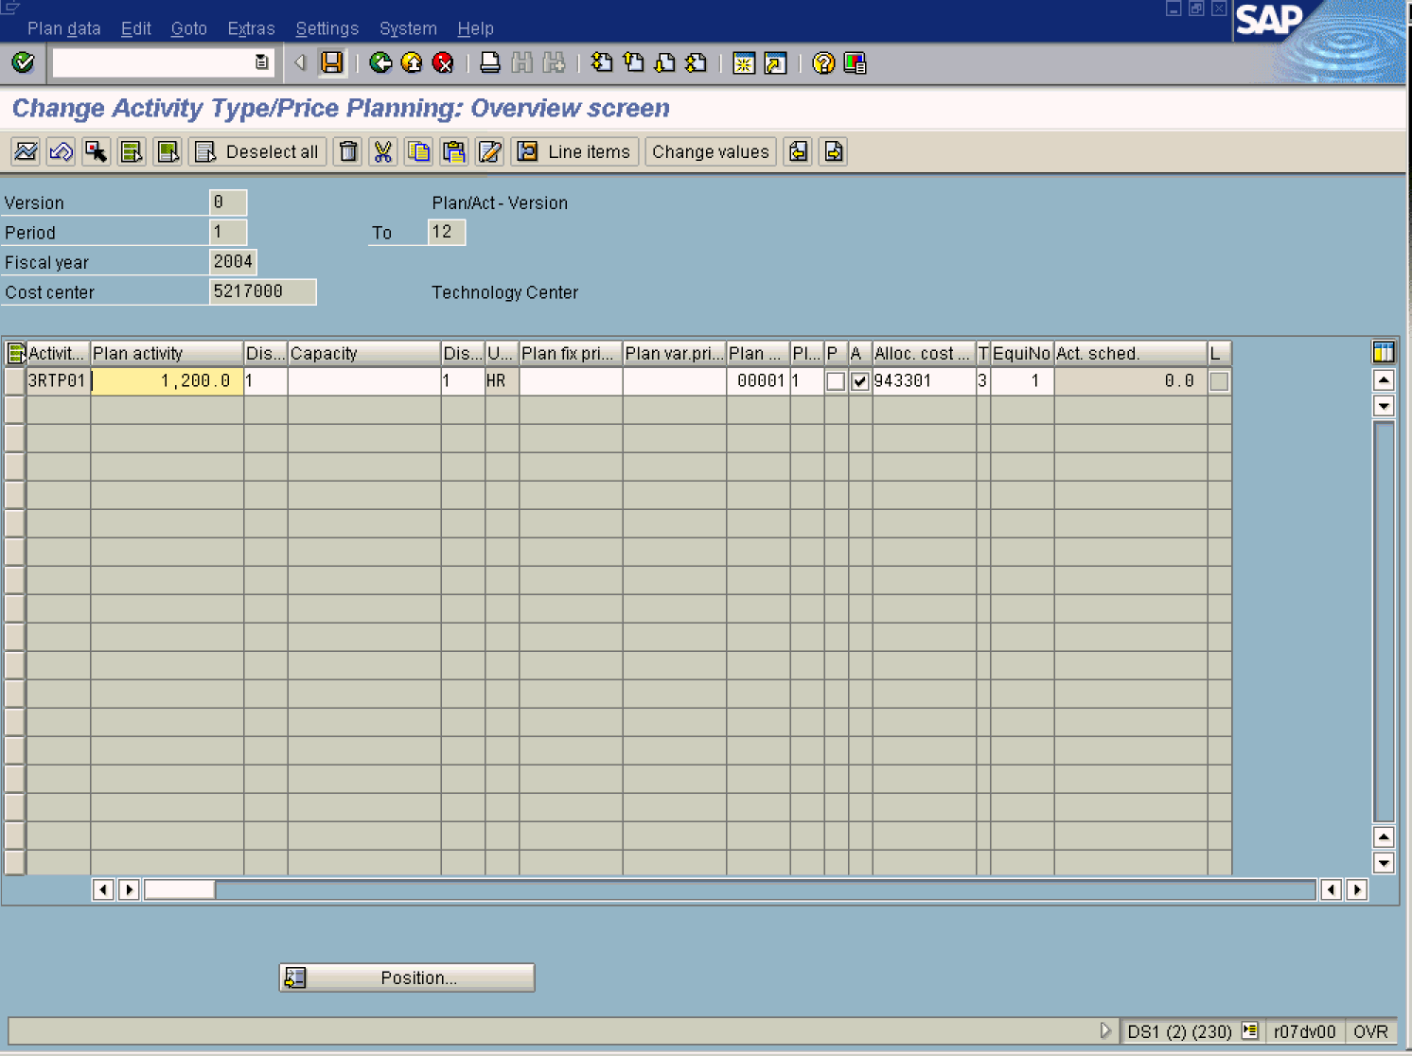
14. Click Save button.
15. The message bar displays “Changed planning data has been posted”

